Anadolu Mandasında Süt Bileşenlerinin Laktasyon Süresince Değişiminin Araştırılması

M.İ. Soysal¹, H. Güven², E.K. Gürcan¹, S. Genç³

¹Namık Kemal Üniversitesi, Ziraat Fakültesi, Zootekni Bölümü, Tekirdağ,
² Silivri İlçe Gıda Tarım ve Hayvancılık Müdürlüğü, İstanbul,
³ Ahi Evran Üniversitesi, Ziraat Fakültesi, Tarımsal Biyoteknoloji Bölümü, Kırşehir.

Özet
Çalışmada ülkemizde yetiştirilen Anadolu mandalarına ait çeşitli süt bileşenleri saptanmış ve bu süt bileşenlerinde laktasyon boyunca meydana gelen değişkenlik farklı modeller kullanılarak incelenmiştir. Süt bileşenleri olarak yağ, protein, laktoz, kuru madde ve somatik hücre sayısı ele alınmıştır. Çalışmada Wood, Grossman, Wilmink ve Mixed-log modelleri kullanılmıştır. Süt bileşenleri için yapılan çalışmada, yağ yüzdesi ortalama % 7.92 olup modeller içinde belirleme katsayılarına bakıldığında en uygun modelin Mixed-log modeli, laktoz yüzdesi ortalama % 5.14 ve yapılan modellemede en uygun model olarak Wood modeli görülmüştür. Protein yüzdesi ortalama % 4.09 olarak hesaplanmış ve modellemede en uygun model olarak Wilmink modeli görülmüştür. Somatik hücre sayısı ortalama 207.000 olarak bulunmuştur. Yapılan modellemede modellerin bu bileşen için model uyumu düşük bulunmuştur. Kurumadde yüzdesi ise ortalama % 18.19 olarak bulunmuştur. Hayvanların ortalama laktasyon süresi 270 gün ve toplam laktasyon süt verim ortalaması 1569 kg olmuştur.
Anahtar Kelimeler: Anadolu Mandası, Laktasyon, Süt Bileşenleri.

The Investigation of Milk Components at During Lactation Period in
Anatolian Water Buffalo

M.I. Soysal¹, H. Guven², E.K. Gurcan¹, S. Genc³

¹ Namık Kemal University, Faculty of Agriculture, Department of Animal Science, Tekirdag,
² Silivri Directorate of Food, Agriculture and Livestock, Istanbul,
³ Ahi Evran University, Faculty of Agriculture, Department of Agricultural Biotechnology, Kırsehir.

Abstract
This study was aimed that determining milk components of water buffalo and milk’s coming out of inconstancy during lactation period by using different models. In this study, fat, protein, lactose, dry matter and somatic cell count dealt as components of milk. Wood, Grossman, Wilmink and Mixed-log are used as models in this study. The fat percentage was averagely 7.92%, when coefficient of determination is treated between models, it was showed that the best fit model is Mixed-Log model, lactose percentage was averagely 5.14% and Wood model was the best fit model. Protein percentage was 4.09% and on modeling the Wilmink model was founded as the best fit that. The average somatic cell count was found as 207.000. In committed model fitting for this component was found low. The average dry matter percentage was found 18.19%. Additionally, animals’ average lactation period and total lactation milk yield were found 270 days and 1569 kg, respectively.

Keywords: Anatolian Water Buffalo, Lactation, Milk Component.

Introduction
In this study, it is intended to research the change in milk components over time, throughout the lactation period of Anatolian water buffaloes breeded in İstanbul region. Besides, it is also intended to contribute to the studies on the milk characteristics of Anatolian water buffaloes.
In Turkey, by the end of 2013, total number of buffaloes, number of milking buffaloes, and total buffalo milk production have increased to 117591 heads, 51940 heads and 51947 tons, respectively. In 2012, the total number of buffalo, the number of milking buffalo, and the total buffalo milk production in the province of İstanbul, were reported as 10560 heads, 4994 heads, and 5.362 tons, respectively. Approximately 10% of the buffalo milk production of Turkey takes place in the province of İstanbul (Anonymous, 2014).
In Turkey, there was a rapid decrease in the number buffaloes, resulting from the deterioration of convenient environmental conditions over time and inability to use the products economically. Due to the carried out projects, given incentives and support, the number of buffalo has demonstrated a tendency to increase in the recent years (Gürcan et al. 2011).
In Turkey, buffalo breeding is evaluated in the aspect of milk and meat products. Buffalo milk is used most notably in production of kaymak, yogurt, cheese, and ice-cream, while buffalo meat is particularly used in sucuk production. In Turkey, buffaloes are mostly available in middle Black Sea Region and İstanbul. Buffalo's milk differs in composition from cow's milk. Particularly, with respect to the fat content, buffalo's milk is fatter than cow's milk with %7-8 fat content. Percentage of the fat varies according to the lactation period. Towards the end of lactation, percentage of fat increases more and may reach to the levels of 12,5-15% (Düzgüneş 1960; Kreul and Sarıcan 1993).
In a similar way, Adam (1975) has also reported that fat ratio and protein ratio of milk in Anatolian water buffaloes, have been demonstrating an increase towards the end of lactation period. In the study, it is reported that fat was 6,7%, protein value was 4,9%, and dry matter substance was 10,2%, during the 4th week of lactation. İlaslan et al. (1983) have stated that the fat ratio in buffalo milk, was ranging from 6.26% to 9.72%, so that they attained the mean fat as 8%.
In their study on components of buffalo milk, Soysal et al. (1996), have found protein, total dry matter, fat, and water percentages as 4,1%, 17%, 8,1%, and 82,2%, respectively. According to the order of lactation, the highest average protein content was in the fourth lactation (4,4%) and the highest average fat content was in the sixth lactation (9,1%). Studies dealing with the composition of buffalo milk, have accentuated the fat value of buffalo milk and it was found that the value was between 4-16%. In terms of fat content, there are significant differences among species. The average fat content of buffalo, cow, sheep, and goat are 7,7%, 3,4%, 7,2%, and 4,3%, respectively (Sosyal 2009). Madad et al. (2013) have researched some factors which effect various yield traits. Accordingly, results of the study indicated that total milk yield was 1420,54 kg, fat yield was 99,83 kg, and percentage of fat was 7,01%, as average values.
Yadav et al. (2013) have studied the biochemical changes in the milk of Murrah buffaloes in the course of lactation period by utilizing milk samples of 100 buffaloes from 7 different institutes. In the framework of study, they have analysed the effects of season and lactation period over milk components and yield. Thereafter the results have indicated that the average lactation duration was 322,6 days. Moreover, effects of lactation duration on milk yield, fat percentage, protein, and lactose, were found to be in the ranges of 9.5 kg to 4.3 kg, 7.19% to 8.63%, 3.46% to 3.56%, and 4.36% to 4.60%, respectively. Consequently, they have stated that protein and lactose contents were exhibiting the least change.It is also noted that peak milk yield have been attained on the 42th day of lactation.
A study has been conducted in Anatolian water buffaloes reared in Samsun province, in an effort to understand factors that affect milk composition, and to see whether milk components change according to lactation periods. The study presented that lactation period has an impact on each one of the component rates except for ash rate. However, it was found that lactation period has an important effect on calving season, non-fat solids, and casein rates. Standardized total dry matter, non-fat dry matter, ash, fat, protein and casein rates were found to be 16.6%, 9.6%, 0.7%, 7.1%, 4.4% and 3.1%, respectively. It is observed that total dry matter, non-fat dry matter, fat and casein rates have been changing on a statistically significant level (Şekerden et al. 1999).
Muhammed (2009) has compared the performance characteristics of Pakistani Nili Ravi buffaloes and Indian Murrah buffaloes and Egyptian buffaloes. According to the results, it is reported that 1st lactation milk yields of Nili-Ravi, Murrah and Egyptian buffaloes, were 1854 kg, 1654 kg, and 1185 kg, respectively, while 3rd lactation milk yields were 2396, 2056, and 1678 kg and percentage-of-fat values were 6.4, 6.6, and 6.5, in the same order. In case of Chinese buffaloes, the same researcher has reported that fat, protein, lactose, dry matter, and water vary in the ranges of 7,40-11,67%, 4,50-5,95%, 3,69-4,83%, 3,69-4,83%, and 78,24- 81,26%, respectively. On the other hand, it has been stated that in Italian buffaloes, average fat was 8,2% and average protein was 4,5%. Also, in different stages of lactation, the highest protein percentage was on the 300th day of lactation (4,67), while the lowest protein percentage was on the 120th day (4,04).
Daily averages of fat, protein, and lactose in colostrum milk of buffaloes, were determined for the 1st day of lactation as 8,3%, 17,36%, and 3,26%, while data from the 7th day indicated same values as 4,8%, 4,84%, and 4,89%, respectively.
The same researcher has also conducted a study in Azeri buffaloes, in order to determine the change in milk yield, fat, and protein values over the course of 10 lactations. Thus, average milk yield, fat percentage, and protein percentage were found as 1103 kg, 7,89% and 4,57% for the 1st lactation, respectively. However, these parameters were found as 1302 kg, 8,07% and 4,40% for the 10th lactation, in the same order. In an effort to calculate averages for the best lactation milk yield in Italian buffaloes, it was found that 90 buffaloes were producing 2587 litres milk in average 322,9 days, with a mean fat content of 7,4% (Muhammed 2009).
Also, recording of changes in milk components and milk yields of Anatolian water buffaloes in the time course of lactation, and modelling the time-dependent changes in these parameters represent the scope of this study, which will contribute to the other studies on this subject.
Material and Method
The material of this study consists of 41 heads Anatolian water buffaloes from 7 villages (Çeltik Köyü, Danamandıra Köyü, Nakkaş Köyü, Yeniköy, Tayakadın Köyü, Merkez, and Işıklar Köyü) and 5 districts (Silivri, Çatalca, Arnavutköy, Kağıthane, and Eyüp) of the province of İstanbul that reared in 8 buffalo breeding enterprises with similar care and feeding conditions. On the other hand, the animal material in the study, have been chosen randomly from 3-4 years old buffaloes reported to be identical in terms of order of lactation. Due to the variance analysis, the animals were also determined to be homogeneous. In the study, ratio of animals in the first two lactations to the entire herd was 65%.
Following the birth, in every 15 days, milk samples were collected with 50 cc containers from the 41 buffaloes which defined to be material of study. The transport of samples was done by using chemical tablets (Microtabs II) that preventing the structure of milk from disruption and that stopping microbial growth without affecting somatic cell count or milk components. Subsequently, the samples were transported to İstanbul University, Faculty of Veterinary Medicine, Department of Animal Science laboratory in cold chain. Following this, the milk samples were warmed up in water bath (in 40°C) and somatic cell count, fat, protein, lactose, and dry matter values were determined. Combi 150 (Bentley), which is a device made by integration of Somacount 150 (somatic cell count device) and Bentley 150 (milk component measuring device) and which uses flow cytometry analysis method, has been used in performing analysis on the milk samples at the department of Animal Science. The device and its analysis methods are approved by international organizations.
In order to examine the change in milk yield and milk components over time, regarding to the results obtained from 733 analysis, Wood,Grossman, Wilmink, and Mixed-log models were used (Wood, 1967; Grossman et al. 1986). The models used in this study and their equations are given in Table 1. Aiming at determining the most appropriate one among the models used, compliance criteria known as coefficients of determination and error sum of squares were utilized. On the other hand, the modelling processes and estimates of parameter values for the models used, have been performed in a statistical package software known as Statistica (Statistica, 1994). Estimates of parameter were performed for each model. According to the characteristics of models used in estimation, parameters of a, b, c, and k are used to determine coefficients of initial milk yield, pre-peak increase rate, post-peak decline rate, and peak-reach time, respectively (Özyurt and Özkan 2009).

Table 1. Models used in the study
Model | Function Format
Wood | Y_{(t)}=at^{b} e^{-ct}
Grossman | Y_{(t)}=at^{b} e^{-ct}(1+uSin(t)+vCos(t))
Wilmink | Y_{(t)}=a + be^{-kt} + ct
Mixed-log | Y_{(t)}= a + b√t + c In (t)

In the framework of this study, for Wood's model and Grossman model, persistance (S) values were calculated to be S=-(1+b)lnc and S=c(-b+1), respectively. From another hand, in the study, maximum milk yield (Y_{max}) and the day that the highest milk yield was obtained (T_{max}) were determined as T_{max}=b/c and Y_{max}=a(b/c)^{b}e^{-b} , respectively (Soysal ve Gürcan 2000).
Satellite map of the locations in the study, from which samples were collected, is shown in Figure 1.
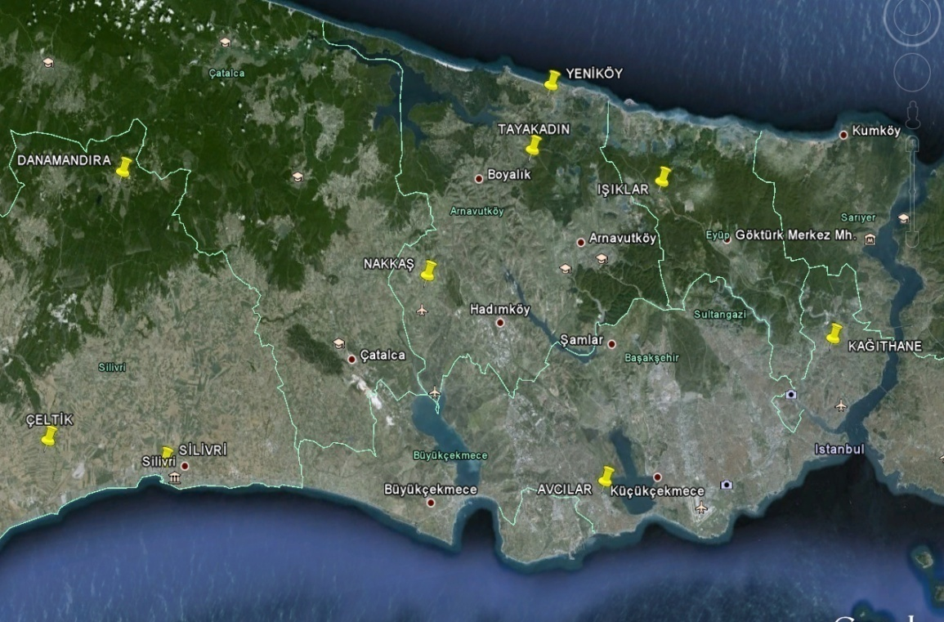
Figure 1. Study area

Findings and Discussion
In the studied animals, it was found that the shortest lactation period was 150 days and the longest lactation period was 355 days. Moreover, average lactation duration was 270 days, total lactation milk yield average was 1569 kg, and average milk fat percentage was 7.92%. Alteration of milk fat component with time was modelled in three different models and the parameters of these models were presented in Table 2.
Accordingly, with regard to the coefficients of determination, Mixed-log model was found to be the most appropriate one. Coefficients of determination for Wood, Wilmink, and Mixed-log models were found to be 0.66, 0.65, and 0.71, respectively.

Table 2. Parameter estimates of milk fat component according to Wood, Wilmink, and Mixed-log models
Milk fat component | a | b | c | K | r | R² | ESS
Wood's model | 5.52 | 0.060 | -0.00067 | - | 0.81 | 0.66 | 13.33
Wilmink model | 4.54 | 1.97 | 0.010 | 0,000004 | 0.80 | 0.65 | 13.70
Mixed-log model | 5.80 | 0.29 | -0.16 | - | 0.86 | 0.71 | 11.17
R²: Coefficient of determination, r: Coefficient of correlation, ESS: error sum of squares
It is determined that dry matter percentage was 18.19%. The change in milk dry matter value with time was modelled in Wood's model. The parameters belonging to the model, were given in Table 3. The coefficient of determination for Wood's model, has been stated as 0.63.

Table 3. Parameter estimates of milk dry matter component according to Wood's model
Milk dry matter | a | b | C | r | R² | ESS
Wood's model | 16.34 | 0.012 | -0.00036 | 0.79 | 0.63 | 10.35
R²: Coefficient of determination, r: Coefficient of correlation, ESS: error sum of squares

The average lactose percentage was 5.14%. The change in lactose component over time , was modelled in Wood and Mixed-log models. The parameters belonging to these models, were shown in Table 4. According to the modelling, Wood's model was found to be the most appropriate model. Also, it was found that determination coefficients of Wood and Mixed-log models, were 0.81 and 0.78, respectively.

Table 4. Parameter estimates of milk lactose component according to Wood and Mixed-log models
Süt laktoz bileşeni | a | B | C | R | R² | ESS
Wood modeli | 5.08 | 0.041 | 0.0010 | 0.90 | 0.81 | 0.42
Mixed-log modeli | 5.20 | -0.16 | 0.28 | 0.88 | 0.78 | 0.47
R²: Coefficient of determination, r: Coefficient of correlation, ESS: error sum of squares

The average protein percentage was found 4.09%. Protein component variation over time , was modelled in Wood, Wilmink, and Mixed-log models. The parameters belonging to these models, were presented in Table 5. Accordingly, Wilmink model was determined as the most appropriate one. From another hand, determination coefficients of Wood, Wilmink, and Mixed-log models, were 0.50, 0.79, and 0.56, respectively.

Table 5. Parameter estimates of milk protein component according to Wood, Wilmink, and Mixed-log models
Milk protein component | a | B | c | k | r | R² | ESS
Wood Model | 4.62 | -0.043 | -0.00053 | - | 0.71 | 0.50 | 0.44
Wilmink Model | 5.97 | -0.86 | 0.051 | -0.004 | 0.89 | 0.79 | 0.45
Mixed-log model | 4.59 | 0.07 | -0.20 | - | 0.74 | 0.56 | 0.39
R²: Coefficient of determination, r: Coefficient of correlation, ESS: error sum of squares

In the study, somatic cell count in the samples, was determined to be 207.000. Time-dependent variation in somatic cell count was modelled in Wood and Mixed-log models. Subsequently, compatibility of the models was determined as low. In Table 6, the parameters related to these models were presented. Results have indicated that Wood and Mixed-log models both had the same determination coefficient value (0.24).

Table 6. Parameter estimates for somatic cell count, according to Wood and Mixed-log models
Milk somatic cell count | A | b | c | r | R² | ESS
Wood Model | 221.120 | -0.015 | 0.00007 | 0.06 | 0.24 | 169999
Mixed-log model | 219.660 | -0.93 | -0.73 | 0.06 | 0.24 | 169935
R²: Coefficient of determination, r: Coefficient of correlation, ESS: error sum of squares

The change in milk components over time, for each one of the models used, has been demonstrated in Figure 2, 3, 4, and 5, separately. Estimated values for the models used, and observed actual values were utilized in the drawing of these figures. Accordingly, as it can be understood from the figures, among the estimated value curves, the closest to the observed value curve, was accepted to be the most appropriate model.

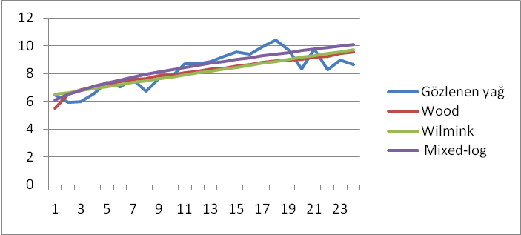
Figure 2. The curves generated for milk fat component, according to observations and Wood, Wilmink, and Mixed-log models
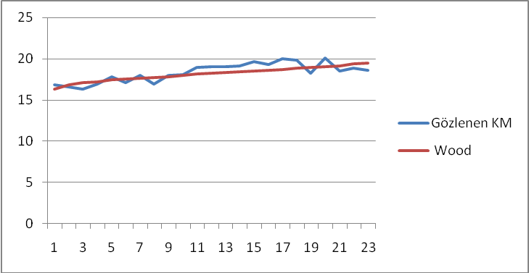

Figure 3. The curves generated for milk dry matter value, according to observations and Wood's model

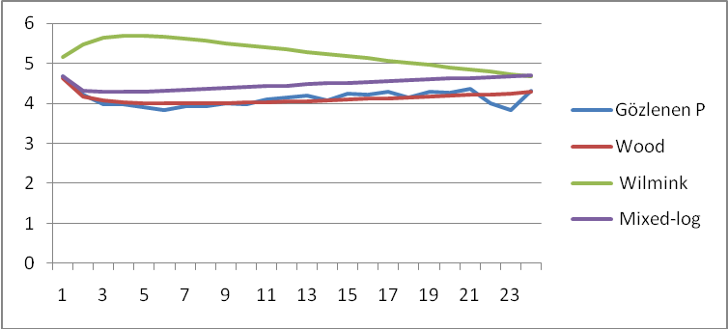
Figure 4. The curves generated for milk protein value, according to observations and Wood, Wilmink, and Mixed-log models

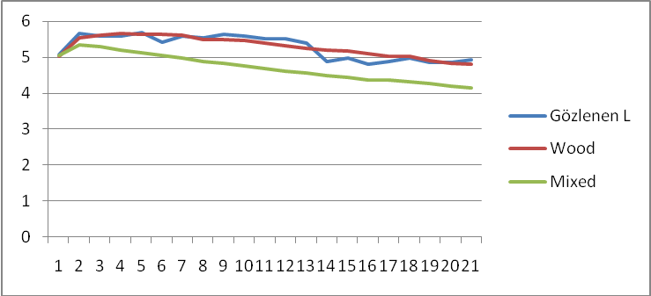
Figure 5. The curves generated for milk lactose value, according to observations, and Wood and Mixed-log models

Discussion and Result
In the study, total 733 milk sample analysis were performed. Results have indicated that milk component averages were 7.92% fat, 4.09% protein, 5.14% lactose, and 18.19% dry matter, while somatic cell count was determined to be 207.000. Milk is the prominent product in buffalo rearing, besides that milk fat content is notably important in milk production as well.
In the studies conducted in this field, Adam (1975) has also reported that, in Anatolian water buffaloes, milk fat content and milk protein content, have been demonstrating an increase towards the end of lactation. In the study, it is reported that fat was 6,7%, protein was 4,9%, and dry matter was 10,2%. İlaslan et al. (1983) have reported that fat content in buffalo milk, was ranging between 6.26% and 9.72%, accordingly, they calculated the mean fat as 8%. Soysal et al. (1996), have determined percentages of protein, dry matter, fat, and water, to be 4,1%, 17%, 8,1%, and 82,2%, respectively. Studies related to the components of buffalo milk, have accentuated the fat value of buffalo milk and it was noted that the value was between 4-16%. Yadav et al. (2013) have analysed the effects of season and lactation period over milk components and yield in Murrah buffaloes.
The results indicated the average lactation period as 322,6 days. On the other hand, the study also determined the impact of lactation duration on milk yield (9.5 kg to 4.3 kg), fat (7.19% to 8.63%), protein (3.46% to 3.56%), and lactose (4.36% to 4.60%). In the study, the peak yield have been observed on the 42th day of lactation. Researchers have also reported that protein and lactose were demonstrating the least change among the other components.
In conclusion, in the study conducted for milk components, average fat percentage was found 7.92% and according to the coefficients of determination, Mixed-log model was regarded as the most appropriate model. Percentages of dry matter and lactose were 18.19% and 5.14%, respectively. Moreover, it is seen that, Wood's model had the best fit. Average protein percentage was found 4.09% and with regards to the modelling, the most suitable model was found to be the Wilmink model. Besides finding average somatic cell count as 207.000, the compatibility of models was found low.

References
Adam RC (1975). Manda Sütü Yardımcı Ders Kitabı Ege Üniversitesi Ziraat Fakültesi Yayınları No: 188 Bornova.
Anonim (2014). TÜİK-Türkiye İstatistik Kurumu, Hayvancılık İstatistikleri. http://www.tuik.gov.tr/PreTabloArama.do, (20.09.2014).
Düzgüneş O (1960). Hayvancılık. Ziraat Vekaleti Mesleki Kitaplar Serisi: D-l. Ankara
Grossman M, Kuck AL ve Northon HW (1986). Lactation Curves of Pure Breed and Crossbreed Dairy Cattle. J.Dairy Sci. 69: 195-203.
Gürcan EK, Soysal Mİ, Küçükkebapçı M, Yüksel MA ve Genç S (2011). Mandaların laktasyon eğrisinin farklı modellerle karşılaştırılması. 7.Ulusal Zootekni Bilim Kongresi, Adana.
İlaslan M, Karabulut A, Aşkın Y, İzgi AN (1983). Yerli Mandalarda Vücut Yapısı, Döl ve süt Verimi üzerine Araştırmalar. Afyon Zirai Araştırma İstasyonu Yayın No: 14 Afyon.
Kreul W, Sarıcan C (1993). Türkiye'de Manda Yetiştiriciliği. Hasad Dergisi Nisan Sayı: 95 Yıl: 8 Beyazıt, İstanbul.
Madad M, Hossein-Zahed NG and Shadparvar AA (2013). A Study of Some Factors Affecting on Productive Traits in Azari Buffaloes of Iran. The 10th World Buffalo Congress and The 7thAsian Buffalo Congress May 6-8, 2013, Phuket, Thailand
Muhammed A (2009). The Animal of Future.Idara Matbuat-E-Sulemani, Lahore, Pakistan.
Özyurt A ve Özkan M, (2009) Orta Anadolu’ da Yetiştirilen Siyah-Alaca Sığırlarda Laktasyon Eğri Şekli ve Eğriye Etkili olan Faktörler. Hayvansal Üretim 50 (1): 31-37.
Soysal Mİ (2009). Manda ve Ürünlerinin Üretimi. Tekirdağ, Yayın no: 978-9944-5405-3-7 , Sayfa: 161-171, Tekirdağ.
Soysal Mİ, Küçük R (1996). Siyah Alaca Süt Sığırlarında Eklemeli Kısmi Verimler İle Birinci Laktasyon Süt Veriminin Tahmin Olanakları Üzerine Bir Araştırma. Tekirdağ Ziraat Fakültesi Dergisi S.284-293 1996.
Soysal MI, Gürcan EK (2000). Comparison of the Mathematical Models in Fitting Lactation Curves for Black and White Cattle Raised in Tekirdağ and Kırklareli. 51. Annual Meeting of European Association for Animal Production, EAAP, 21-24/08, The Netherlands.
Statistica, (1994). Statsoft Inc.Tulsaok, Statistica for The Windows TM.Operating System.
Şekerden Ö, Erdem H, Kankurdan B ve Özlü B (1999). Anadolu Mandalarında Süt Kompozisyonunu Etkileyen Faktörler ve Süt Kompozisyonunun Laktasyon Dönemlerine Göre Değişimi. Tr. J. of Veterinary and Sciences, 23 (1999) 505-509.
Wood, P.D.P. (1967). Algebraic Model of Lactation Curve in Cattle. Nature, 216, 164-1.
Yadav SP, Sikka P, Kumar D, Sarkar S, Pandey AK, Yadav PS and Sethi RK (2013). Biochemical Changes in Milk during Different Parity and Seasons in Murrah Buffaloes. The 10th World Buffalo Congress and The 7th Assian Buffalo Congress, May 6-8, 2013, Phuket, Thailand

