The Estimation of Lactation Milk Yields Using Partial Milk Record in Italian Water Buffalo

M.I. Soysal¹, E.K. Gurcan¹, M. Aksel²

¹ Namık Kemal University, Faculty of Agriculture, Department of Animal Science, Tekirdağ,
²Istanbul Water Buffalo Breeders Association, Istanbul.

Abstract
The research was aimed to provide estimation of total lactation milk yields using partial milk yields of Italian water buffalo, in earliest period. In this study, the descriptive statistics of total lactation milk yield, daily milk yield and lactation period were found as 1694.3 ± 428.2 kg, 7.2 ± 1.3 and 232.8 ± 40.6 in Italian water buffalo, respectively. At the same time, the relationship between total milk yield and partial milk yield was analyzed and some determination coefficients were found as 0.40, 0.94 and 0.99 for 15, 210 and 300 days, respectively. For instance, regression equation and determination coefficient were calculated for between 60 days partial milk yield records and total milk yield records as [TMY=102+2,83 (60PMY)] and 48,9 % respectively.
Keywords: Italian Water Buffalo, Partial Milk Yield and Total Milk Yield.

Introduction
Generally, study about water buffalo breeding in Turkey is lower than the other species, in Turkey and the situations are quite primitive in this field. Especially in water buffalo, as the record system was not appropriately applied, breeding studies to increase features of animals’ yield are not able to reach expected level.
Thanks to the established unions and government policies in recent years, there were important attempts about number of water buffalo and breeding. While the number of water buffalo is about increasing in Asia continent, in our country this situation is about sharply decreasing. According to 2015 TUIK’s database, it was reported that total water buffalo number is 133.766 head, number of milking buffalo is 62.999 head. Water buffalo was raised very numerous in Samsun, Tokat, Amasya and İstanbul province of Turkey as 43.958 head (TUIK, 2015). Water buffalo’s products are valuable for milk and meat processing. For instance, yogurt, kaymak and sausage made from buffalo milk and meat are very illustrious and these products are preferable by consumers. Specially, the fat percent of water buffalo’ milk is different from other species’ milk fat.
In studies before, water, dry matter, fat and protein percentage in water buffalo milk have found as 82.2%, 17.8%, 8.1% and 4.1% respectively, (Sosyal and Küçük, 1996). Madad et al. (2013), have reported that total milk and fat yield were found 1420.5 kg and 99.8 kg in Azerbaijan buffalo, respectively. Moreover, heritability of total milk yield and fat percentage were detected as 0.14 and 0. 35 and the fat percentage was found 7.01% also. Eventually, researchers stated that, these features are used successfully by accordance with heritability in animal breeding. Garcia et al. (2013), have detected the average milk yield and lactation period as 864 kg and 244 days, respectively. Muhammed (2009), also reported that the average milk yield, lactation period and fat percentage were found as 2587 liter, 322.9 days and 7.4%, in Italian water buffalo, respectively. At the same time, the first, third lactation milk yields and fat percentages of Nili Ravi, Murrah and Egyptian water buffalo were found 1854, 1654 and 1185 kg; 2396, 2056 and 1678 kg and 6.4, 6.6 and 6.5%, respectively (Mohammed A. 2009).
In order to assess the genetic capacity of farm animal as quickly, milk yield of these animals should be identified early age and accurately. Therefore, the partial milk yields are used to estimate the total lactation yields. Similarly, Malhado et al. (2013), recommended that due to the high repeatability of milk yield, the first lactations could have used a selection criterion in animal breeding. Ragnon and Brambilla (1957), were reported that the correlation coefficient between 70-days partial milk yield and total milk yield was found as 0.52 in cattle in Italy. However, Rendel et al. (1957), have found the same value as 0.80. Goodall ve Sprague (1985), indicated that partial milk yields, which were obtained in the 10th week of lactation, have been more useful to estimate total lactation milk yield. In Brown cattle, Tuncel (1971), has calculated the coefficient of determination between 30-days and 150-days of monthly, and partial milk yields and total yield as 0.596 and 0.861, in Brown Swiss cattle respectively. Soysal and Küçük (1996), were noted that in order to estimate the total lactation yield from partial yield, the linear regression equation could be utilized as (Y=502.919+1.261X), by using 180-days partial yield as (X) and total lactation yield as (Y) in Holstein cattle. On the other hand, Keskin and Boztepe (2011) have used the first lactation yield records of Holstein cattle, which were raised in a private farm in Konya. They have been found that, high and statistically significant correlation for partial lactation records and 305 days milk yield 0.701-0.979. Consequently, they reported that 305-day milk yield could be simply detected from the first 30 days of lactation records. Soysal et al. (2015), reported that, milk component averages were 7.92% fat, 18.19% dry matter, 5.14% lactose, 4.09% protein and 207.000 somatic cell count in Anatolian water buffalo, respectively. The relationship between total milk yield and partial milk yield was analyzed. It was found that the determination coefficient was estimated between total milk yield and partial milk records of 150 days as 0.51.
This research was aimed to investigate relationship between partial milk yield with total milk yield in Italian water buffalo. At the same time, this research was compared total milk yield by means of partial milk yields. Due to partial milk yields could be detected by early lactation period. Finally, partial milk yields are used to forecast total milk yield in water buffalo.
Materials and Methods
The animal material was consist of 72 head Italian water buffalo from a private farm in Istanbul. Whole animals were reared in similar management and feeding conditions. In the study, daily milk yield records have been used, which were obtained by measuring daily milk yield in the morning and evening from the beginning to the end of daily lactation. The animals that raised in the same conditions were detected as homogeneous groups regarding to age and lactation number. On the other hand, partial milk yield records were collected from 15 day till 300 day. The correlation and regression analysis between total lactation milk yield with partial milk yield of the animals were determined and this relationships were compared with coefficient of determination (R²). For this, partial milk yields and total milk yields were accepted as independent variable and dependent variable, respectively. Thereby, correlation and simple regression analysis methods were used (Y=a+bX) in present study. The model with the highest coefficient of determination was identified as the most appropriate model (Soysal, 1993). Parameter estimates of regression equations were calculated with Statistica package programme (Statistica, 1994). Owing to significant relationships found this way, total milk yield of animal will be able to be estimated in a shorter time by using partial milk yields, without waiting for the end of the lactation.
Results and Discussions
In present study, the average values for lactation period, total milk yield and daily milk yield were calculated 232.8 day, 1694.3 kg and 7.2 kg in animal, respectively. At the same time, the mean of partial milk yields were shown for 15- 300 days in Table. 1.
The correlation coefficients between total milk yield and partial milk yields were presented in Table 2. For instance, correlation coefficients of total milk yield with partial milk yields (30 days and 90 days) were calculated as 0.54 (P<0.01) and 0.76 (P<0.01) respectively. Also, the correlation coefficient between total milk yield and 150-day partial milk yield, has been found as (r=0.85**). The regression equations and determination coefficients were presented in Table 3. The regression lines and distributions were plotted between 15, 30. 60, 90, 150 and 240 days partial milk yields with total milk yield in Figure 1.

Table 1. The mean and standard deviations for partial milk yields, total milk yields and lactation period
 | N | Mean ± Standard Deviation
LP | 72 | 232,8 ± 40,6
TMY | 72 | 1694,3 ± 428,2
DMR | 72 | 7,2 ± 1,3
15 PMY | 72 | 134,9 ± 32,3
30 PMY | 72 | 280,4 ± 59,5
45 PMY | 72 | 422,5 ± 83,3
60 PMY | 72 | 556,7 ± 106
90 PMY | 72 | 803,7 ± 148,6
120 PMY | 72 | 1038,2 ± 193,6
150 PMY | 72 | 1247 ± 234,5
180 PMY | 71 | 1411,5 ± 274,4
210 PMY | 65 | 1559,6 ± 313,2
240 PMY | 54 | 1724,1 ± 317,8
270 PMY | 32 | 1900,5 ± 309,5
300 PMY | 11 | 1969,9 ± 333,5
TMY: Total Milk Yield, LP: Lactation Period, DMY: Daily Milk Yield, PMY: Partial Milk Yield

Table 2. The correlation coefficients and significance test results (15-300 days) of partial milk yields and total milk yield values
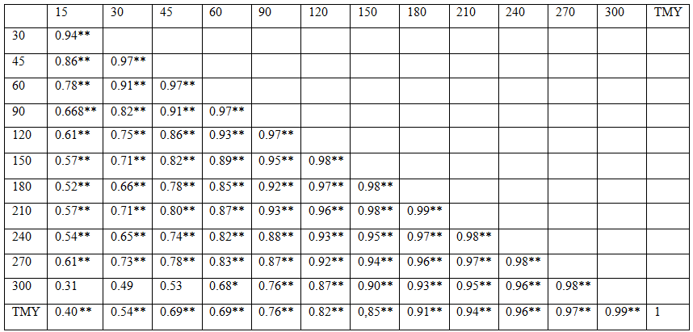
*: P<0.05, **:P<0.01, TMY: Total Milk Yield

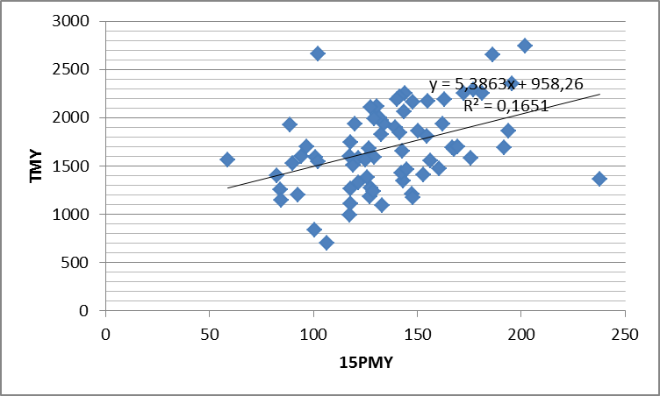
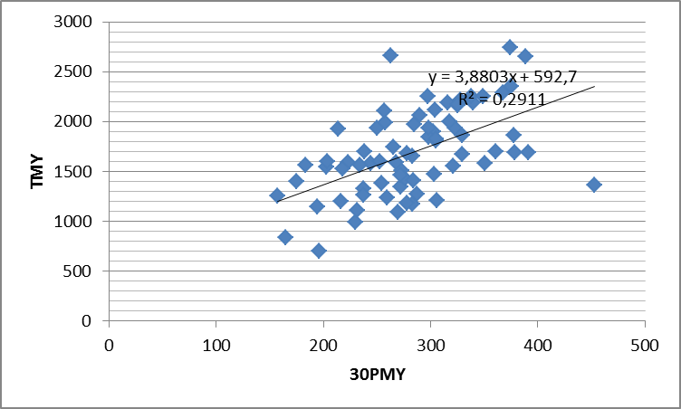
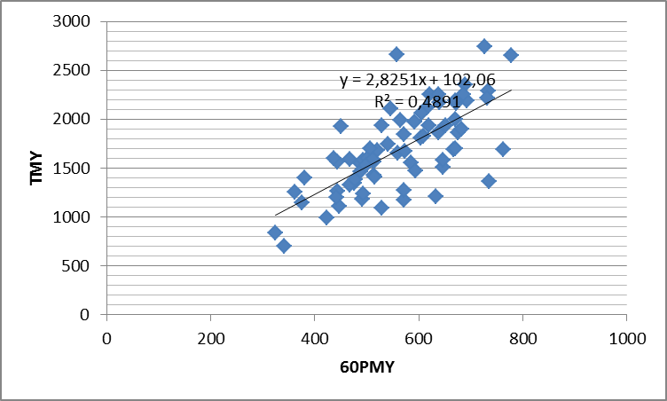

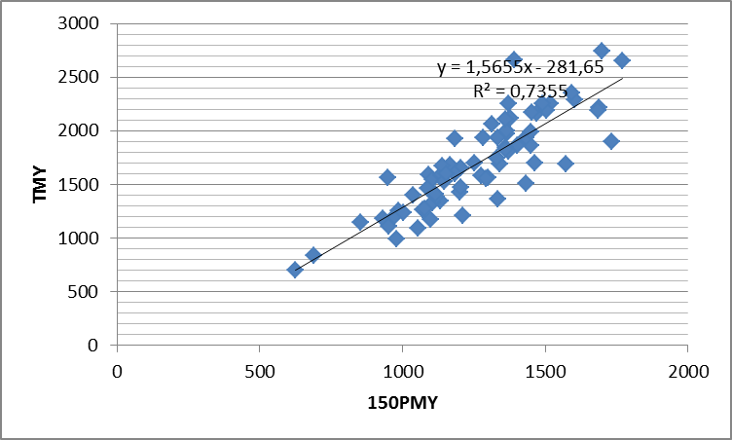
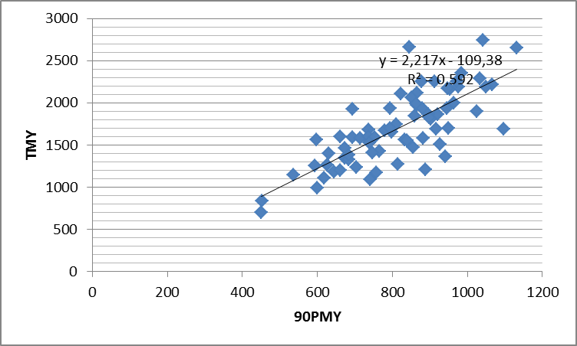
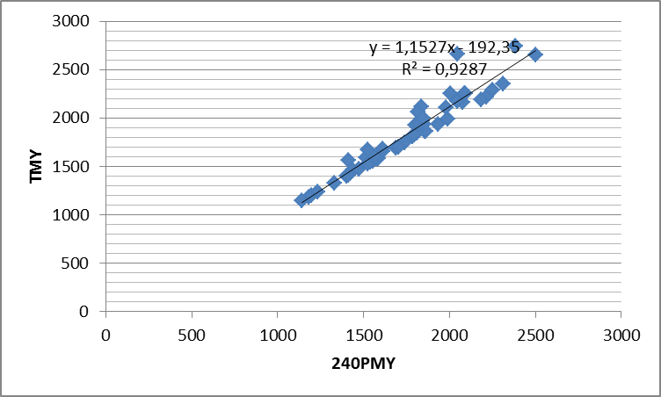
Figure 1. Distributions and the regression lines between 15, 30, 60, 90, 150 and 240 days partial milk yield with total milk yield.

In this study, the means of lactation period and total milk yield were estimated as 232,8 ± 40,6 days and 1694,3 ± 428,2 kg. The relationships between total milk yield and partial milk yield were researched. The coefficient of determination was found as 48.9 % between total milk yield and partial milk yields of 60 days.

Table 3. Regression equations (Y = a + bX), and determination coefficients for 15-300 days (partial milk yields as independent variables and total milk yield values as dependent values).
Partial Yields  According to Days | Regression Equation  (Y=a+bX) | Coefficient of Determination (R²) %
TMY=a+b (15PMY) | TMY=958+5,39 (15PMY) | 16,5
TMY=a+b (30PMY) | TMY=593+3,88 (30PMY) | 29,1
TMY=a+b (45PMY) | TMY=289+3,29 (45PMY) | 40,9
TMY=a+b (60PMY) | TMY=102+2,83 (60PMY) | 48,9
TMY=a+b (90PMY) | TMY=-109+2,22 (90PMY) | 59,2
TMY=a+b (120PMY) | TMY=-217+1,82 (120PMY) | 67,7
TMY=a+b (150PMY) | TMY=-282+1,57 (150PMY) | 73,5
TMY=a+b (180PMY) | TMY=-323+1,42 (180PMY) | 82,7
TMY=a+b (210PMY) | TMY=-295+1,28 (210PMY) | 89,8
TMY=a+b (240PMY) | TMY=-192+1,15 (240PMY) | 92,9
TMY=a+b (270PMY) | TMY=-136+1,09 (270PMY) | 95,3
TMY=a+b (300PMY) | TMY=-127+1,07 (300PMY) | 98,6
b:regression coefficient, a: intercept, PMY: Partial Milk Yield

Ragnon and Brambilla (1957), reported that the correlation coefficient of 70-day partial milk yield and total milk yield was found to be 0.52 in Holstein cattle in Italy. Rendel et al. (1957) have found the same value as 0.80. On the other hand, Goodall and Sprague (1985) have indicated that partial milk yields from the 10th week of lactation, were more efficient to estimate total lactation in comparison to other periods. The coefficient of determination between 30 and 150 days partial milk yields and total milk yield were calculated as 0.596 and 0.86, respectively (Tuncel, 1971). Keskin and Boztepe (2011), stated that, from the first 30-day partial lactation records, 305-day milk yield could be easily detected in Holstein cattle. Soysal et al. (2015), reported that the relationship between total milk yield and partial milk yield was analyzed in Anatolian water buffalo. It was found that the determination coefficient was estimated between total milk yield and partial milk records of 30 and 150 days as 0.43 and 0.51 respectively. The relationship between total milk yield and partial milk yields was analyzed, In present study, 15-300 days of determination coefficients between partial milk yields and total milk yields, have been found to be between 16.5 and 98.6 % in Italian water buffalo.
Finally, this research was compared total milk yield by means of partial milk yields. Thus, partial milk yields are used to forecast total milk yield formerly in water buffalo.

References

Garcia Y, Fraga LM, Tonhati H, Abreud D, Aspilcueta R, Hernandez A, Padron E, Guzman G, Mora M and Quinonez D (2013). Genetic Parameter Estimates for Milk Yield and Lactation Length in Buffalo. The 10th World Buffalo Congress and The 7th Asian Buffalo Congress, May 6-8, 2013, Phuket, Thailand
Goodall EA, Sprague SD (1985). A Bayesian Estimation of the Lactation Curve of Dairy Cow. CAB Abstracts 1984-1986 Animal Production 1985, 40: 2, 189-193
Keskin İ, Boztepe S (2011). Siyah Alaca Sığırlarda Kısmi Süt Verimlerinden Yararlanılarak 305 Günlük Süt Veriminin Tahmini. Tekirdağ Ziraat Fakültesi Dergisi, (8),1.
Madad M, Hossein-Zahed NG and Shadparvar AA (2013). A Study of Some Factors Affecting on Productive Traits in Azari Buffaloes of Iran. The 10th World Buffalo Congress and The 7th Asian Buffalo Congress, May 6-8, 2013, Phuket, Thailand
Malhado CHM., Ramos AA., Carneiro PLS., Souza JC and Carilo JA, (2013). Genetic Parameters for Milk Yield and Lactation Length of Crossbred Buffaloes from Brazil by Bayesian Inference. The 10th World Buffalo Congress and The 7th Asian Buffalo Congress, May 6-8, 2013, Phuket, Thailand.
Muhammed A., (2009). The Animal of Future. Idara Matbuat-E-Sulemani, Lahore, Pakistan.
Ragnon G, Brambilla E., (1957). Is it Possible to Simplify Milk Recording by Limiting the Time of Collecting the Production Data A.B.A. 1957, 26: 382, 137
Rendel JM., Robertson A., Asker AA., Khiskin SS., Regap MT., (1957). The Inheritance of Milk Production Characteristics, Journal of Agricultural Sci. 48: 426-432.
Soysal MI., (1993). Biyometrinin Prensipleri (I ve II Ders Notları), Tekirdağ Ziraat Fakültesi Ders Notu, S. 293, 1996.
Soysal MI., Küçük R., (1996). Siyah Alaca Süt Sığırlarında Eklemeli Kısmi Verimler İle Birinci Laktasyon Süt Veriminin Tahmin Olanakları Üzerine Bir Araştırma. Tekirdağ Ziraat Fakültesi Dergisi S.284-293 1996.
Soysal MI., Güven H., Gurcan EK., Genc S. (2015). The Estimation of Lactation Milk Record with Partial Milk Record in Anatolian Water Buffalo. Asian Buffalo Congress 2015, İstanbul-Turkey, Book of Abstract, , p:67.
Statistica, (1994). Stat Soft Inc. Tulsaok. Statistica for The Windows TM. Operating System.
Tuncel E., (1971). Koças Devlet Üretme Çiftliğinde Yetiştirilen Esmer Sığırlarda Kısmi Verimlerden Toplam Süt Veriminin Tahmini ve Bundan Seleksiyonda Yararlanma Olanakları Üzerine Araştırmalar Doktora Tezi, Ankara Üniversitesi Ziraat Fakültesi, Zootekni Bölümü.
TÜİK, (2015). Hayvancılık İstatistikleri, http://www.tuik.gov.tr/PreTablo.do?alt_id=1002

