The Comparison of Lactation Curve with Different Models in Italian Origined Water Buffalo Herd Raised in Istanbul Province of Turkiye
M.Ihsan SOYSAL^{1,*} Eser K. Gurcan¹ M. Aksel²

¹Namık Kemal University, Faculty of Agriculture, Department of Animal Science, Tekirdag, Turkey
²Istanbul Water Buffalo Breeders Association, Istanbul- Turkey
*Sorumlu yazar: E-mail: misoysal@nku.edu.com.tr
Geliş Tarihi (Received): 11.07.2016 Kabul Tarihi (Accepted): 20.09.2016

This study was aimed to investigate biometry of lactation curve for Italian origined water buffalo in Istanbul province of Turkey. Total 72 head Italian origined water buffalo were used at first lactation and three calving seasons as animal material. Wood, Wilmink and Cobby and Le Du models were chosen in present study. The general average lactation length, total lactation milk yield average and average daily milk yield were found 234 days, 1607.4 kg and 6.86 kg, respectively. Determination coefficient was calculated for Wood, Wilmink and Cobby and Le Du models for summer calving season as 0.94, 0.92 and 0.93, respectively. Wood model was found the highest coefficient of determination in general. Moreover, persistency (S) and maximum milk yields (Y_{max}) for Wood model were calculated. These values were found as 5.89 and 9.76 for first lactation in general group, respectively. Finally, this study is showed that the Wood model has the best fitted model among all models for all groups for first lactation for Italian origined water buffalo,
Keywords: Wood, Wilmink, Cobby and Le Du Models, Italian Water Buffalo, Lactation Curve

Türkiye İstanbul İlinde Yetiştirilen İtalyan Orijinli Manda Sürülerinde Farklı Modeller ile Laktasyon Eğrilerinin Karşılaştırılması
Bu çalışmada Türkiye’de İstanbul ilinde yetiştirilen İtalyan orijinli mandalarda laktasyon eğrilerinin biyometrisi araştırılması amaçlanmıştır. Hayvan materyali olarak üç malaklama mevsiminde ve ilk laktasyonda olan 72 baş İtalyan orijinli manda kullanılmıştır. Sunulan çalışmada Wood, Wilmink ve Cobby ve Le Du modelleri seçilmiştir. Genel ortalama laktasyon süresi, toplam süt verim ortalaması ve günlük ortalama süt verimi sırasıyla 234 gün, 1607,4 kg ve 6.86 kg olarak bulunmuştur. Yazın malaklayan hayvanlarda Wood, Wilmink ve Cobby ve Le Du modelleri için belirleme katsayıları sırasıyla 0.94, 0.92 ve 0.93 olarak bulunmuştur. Genel olarak Wood modeli en yüksek belirleme katsayısına sahip olmuştur. Bunun yanında, Wood modeli için persistens (S), maksimum süt verimi (Y_{max}) değerleri hesaplanmıştır. Bu değerler ilk laktasyon için sırasıyla 5.89 ve 9.76 olarak bulunmuştur. Sonuç olarak çalışma göstermiştir ki ilk laktasyondaki İtalyan orijinli mandalarda tüm gruplar için diğer modeler içinde en iyi uyum Wood modelinde görülmüştür.
Anahtar Kelimeler: Wood, Wilmink, Cobby ve Le Du Modeli, Italian Manda, Laktasyon Eğrisi

Introduction
Water buffalo is an important animal between the other farm animals from the point of special value of milk and meat production. Recently, In spite of the fact that the breeding is still generally done under extensive conditions the water buffalo population is increasing in Turkey. Water buffalo milk is used in production of kaymak, cheese, and ice-cream. Also, buffalo meat is used in sausage production. Especially, buffalo milk is fatter than cow’s milk with a fat content of 7-8% (Soysal, 2009). By the end of lactation, fat content increases more, and besides that it may reach to the levels of 12,5-15% (Kreul and Sarıcan, 1993). The buffalo are the second largest source of milk supply in the world. The average fat content in buffalo milk is about 7 to 8% while protein content in buffalo milk ranges from 4.2 to 4.5% (Thomas, 2008). Considering statistical data, in 2013, the total number of water buffalo has increased to 117591 heads, the number of milking water buffalo has increased to 51940 heads and the amount of water buffalo milk production has reached to 51,947 tons (Anonymous 2014). Many studies have realized about water buffalo breeding as to increase water buffalo production in the world.
Nili Ravi buffaloes’ average lactation period and average lactation milk yield were found 317 days and 2219 kg in Pakistan, respectively. Furthermore, the first lactation milk yields were found in Nili Ravi, Murrah, and Egyptian buffaloes as 1854, 1654 and 1185, respectively. As to Italian buffaloes the producing was found as 2587 kg of milk on average 322,9 days (Muhammed, 2009). Malhado et al. (2013) have found milk yield and lactation period of crossbred buffaloes as 1546 kg and 252 days, respectively. Hasanpur et al. 2013 are showed in which some environmental factors and traits of various lactation curves. In this study, calving age, calving season, year of birth and year of calving were found statistically important factors on the lactation curve characteristics (P <0.05). In addition to this, it was reported that non-genetic factors have a significant role in determination of total milk yield and lactation in buffaloes. Garcia et al. (2013), are reported that 244-day mean milk yield and lactation period were 864 kg and 240 days, respectively. Additionally, while the heritability of milk yield and lactation length were detected to be 0.15 and 0.13, respectively, the genetic correlation between these properties, has found to be 0,63.
Lactation curve’s shape is a significant criteria. It is possible to draw some conclusions on lactation milk yield of animal. For instance, an animal showing little change during lactation is more preferable than an animal giving a large part of milk at the beginning and a little amount after peak yield. In this case, the first animal’s curve is called flat lactation curve, and the second animal’s curve is called the steep lactation curve. In animal breeding practice, animals with flat lactation curve, are preferred over the ones with steep lactation curve (Akbulut et al. 1994). Moreover, Soysal and Mutlu (2005); Kaygısız (1998) are stated that using partial lactation records, lactation curve may be employed in a method of estimating total lactation yield. Shokrollahi and Hasanpur (2014) were reported that the peak yield is accepted the most important factor determining the shape and total milk production of a buffalo. The phenotypic correlation between these parameters is strong and positive.
Logarithmic, logarithmic quadratic, gamma, Wood, Goodall and Grossman and such models were used by Kaygısız (1999) in Turkey. Lactation length and its relationship with economic traits was investigated for 993 Nili-Ravi buffaloes. Lactation length and milk yield were found 289,5 days and 1984 kg respectively (Khan and Chaudhry, 2000).
Milk production traits of 534 Italian buffalo cows were analyzed with a mixed linear model in order to estimate lactation curves pertaining to different ages at calving and different seasons of calving. Average correlations among test day measures within lactation were 0.59, 0.31, and 0.36 for milk yield, fat, and protein percentages, respectively. At the same time, five standard linear functions of time were used to lactation curves. Goodness of fit was satisfactory for five models, although only the five-parameter model was found to fit all the three traits considered very well (Catillo at al. 2002). Dimauro et al. (2005), were researched total 30296 test day milk yield record of Italian water buffalo cows. All date were grouped as herd, age at calving, calving season and year. The four linear models were used to lactation curve as Wood, Wilmink, Ali and Schaeffer and Legendre orthogonal polynomials. Ali and Schaeffer model was found the best fitted model.
In a study, models were used called quadratic logarithmic linear, logarithmic quadratic, linear hyperbolic, inverse polynomial and Wilmink models by comparing different models of lactation curve. Moreover, the highest adjusted R² was detected in logarithmic quadratic model (0.97) and has indicated as the adjusted R² of Wilmink model was 0.86 (Gürcan et al., 2011).
Penchev et al, (2011), were aimed to show the effects of different factors on lactation curve at first-lactation Bulgarian Murrah buffalo cows. These factors were used as age at first calving, pregnancy-related status, lactation month, days in milk, calendar month of calving, and period of calving. The effect of age at first calving was found significantly higher to peak yield. The calendar month of calving and period were not important effect on lactation curve. Şahin et al. (2013), have compared different lactation curve models of Anatolian water buffaloes and Wood, Cobby and Le Du, exponential, parabolic exponential, inverse polynomial, quadratic, logarithmic quadratic and logarithmic linear models were used in defining lactation curve. The results indicated that quadratic logarithmic and quadratic models that produce the highest R² and the lowest RSD values, are showing the best fit. The gamma-type function, exponential function, mixed log function and polynomial regression function were used to estimate lactation curve parameters for test day milk yields in Murrah buffaloes (Sahoo et al. 2014). Şahin et al (2015), were researched 690 lactation curves totally. All lactation were classified as 406 (58.84%) typical, 90 (13.04%) concave and 194 (28.12%) of a decreasing type according to Wood model. The Wood model was recommended as a useful model for breeding programme. In this study, daily milk yield records of Italian origined water buffaloes raised in İstanbul Province of Turkiye were used in modelling lactation curves for first lactation with three calving seasons and determining the most suitable model.

Material and Method
Animal material consisted of total 72 heads Italian water buffalo namely Mediterranean water buffalo population raised in intensive water buffalo farm in İstanbul whose recently imported from Italy. Milk yield records were taken as daily during lactation and which were in the first lactation periods. All animal were grouped to calving season as summer, spring and autumn. The change in yield with respect to time is researched with Wood, Wilmink and Cobby models (Wood, 1967; Wilmink 1987, Cobby and Le Du 1978). From another hand, in determination of the most appropriate one among the models used determination coefficients (R²) and Residual Standart Deviation (RSD) were utilized. RSD=[RSS/(n-p)]^{1/2} and RSS is Residual Sum of Squares, n is the number of observation and p is the number of the parameters. The functions of models (Wood, Wilmink, Cobby and Le Du) have been indicated in Table 1. Modelling processes and parameter estimates of the models used were made in statistical package software Statistica (Statistica, 1994).

Parameter estimates for each one of the models, have been made. Depending on the characteristics of model used in parameter estimation, a, b, c, and k parameters as initial milk yield, pre-peak increase rate, post-peak decline rate, and peak-reach time, respectively and in the this research k parameters was assumed equal to 0,05 for Wilmink model (Özyurt and Özkan 2009). Moreover, in the study, persistence (S) values for Wood’s model, has been found to be S = -(1+b).lnc. The day that the highest milk yield was obtained (T_{max}) and maximum milk yield (Y_{max}), have been calculated to be T_{max}=b/c and Y_{max}=a(b/c)^{b}e^{-b}, respectively (Soysal and Gürcan 2000).

Results and Discussion
At present study, milk yield records of 72 heads Italian water buffalo, have been kept to be used in modelling lactation curve. Additionally, the lowest milk yield and the highest total milk yield were found to be autumn and spring calving seasons as 1260.2 kg and 1780.4 kg, respectively. However, among the animals of which yield records were taken to first lactation, average lactation period was calculated as 234 days and average daily milk yield were calculated as 6.86 kg in general. This results are shown at table 2.

Table 1. The models and their functions
Models | Functions
Wood | Y_{t}=at^{b} e^{-ct}
Wilmink | Y_{t}=a + be^{-kt} + ct
Cobby and Le Du | Y_{t}=a – bt – ae^{-ct}

Table 2. Lactation period (day), total milk yield (kg) and average daily milk yield (kg) according to calving seasons
Calving Seasons | N | Lactation length | Total milk yield | Average daily milk yield
Spring | 5 | 236 | 1780,4 | 7,54
Summer | 59 | 239 | 1639,4 | 6,85
Autumn | 8 | 192 | 1260,2 | 6,58
General | 72 | 234 | 1607,4 | 6,86
Table 3. Parameter estimations according to Wood, Wilmink and Cobby and Le Du models for calving season
Calving Seasons | Models | a | b | c | R² | RSD
Summer | Wood | 7,90 | 0,098 | 0,0044 | 0,94 | 1,00
 | Wilmink | 10,42 | -1,328 | -0,024 | 0,92 | 1,17
 | Cobby and Le Du | 10,20 | 0,022 | 0,8419 | 0,93 | 1,09
Spring | Wood | 5,45 | 0,232 | 0,0062 | 0,64 | 16,85
 | Wilmink | 11,84 | -4,99 | -0,032 | 0,63 | 16,88
Autumn | Wood | 7,88 | 0,112 | 0,0072 | 0,88 | 5,34
 | Wilmink | 10,11 | -0,66 | -0,034 | 0,85 | 5,76
R²= Determination Coefficient, , RSD=Residual Standart Deviation

In the study conducted to model lactation curve of the water buffalo, of which milk yield records were kept, Wood, Wilmink and Cobby and Le Du models were utilized. The parameters estimations related to these models are demonstrated in Table 3. According to the results, initial milk yields of summer calving season for Wood, Wilmink and Cobby and Le Du models were detected as 7.90 kg, 10.42 kg and 10.20 kg, respectively. Subsequently, in the same order, determination coefficients were determined as 0.94, 0.92, and 0.93, respectively. Accordingly, among the models studied, Wood model was the one with the highest determination of coefficient for all calving season.
On the other hand, values of persistency (S), maximum milk yield (Y_{max}) and time of the maximum milk yield (T_{max}), which belong to Wood model, are presented in Table 4 for all calving seasons. Accordingly, for Wood model, persistency values was 5.89, Y_{max} values was 9.76 and T_{max} values was 25.07 for general groups, respectively.
Şahin et al (2015), were found a, b, c, persistency (S), T_{max}, Y_{max}, and R² as 7.14, 0.85, 0.40, 2.68, 63.6, 6.41, 76.33 and 4.94, -0.73, -0.23, 95.40, 7.41 and 71.68, respectively of typical and concave lactation curves for Wood model. The peak yield from all lactation curves functions was found to be highest around 65th day of lactation in Murrah buffaloes. The best function were found mixed log function explaining highest coefficient of determination and in Murrah buffaloes (Sahoo et al. 2014).
The change in observed yield and predicted yield with respect to time is demonstrated in Figure 1, 2 and 3.

Table 4. Persistence, Y_{max} and T_{max} values of Wood models according to calving seasons
Calving Seasons | S | Y_{max} | T_{max}
Summer | 5,95 | 9,70 | 22,27
Spring | 6,26 | 10,01 | 37,41
Autumn | 5,48 | 9,57 | 15,55
General | 5,89 | 9,76 | 25,07

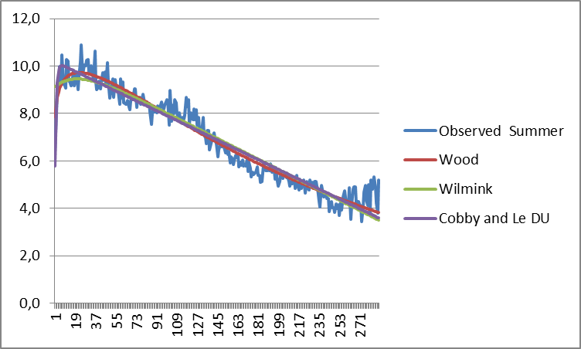
Figure 1. Lactation curves of Wood, Wilmink and Cobby and Le Du models for calving season of summer.

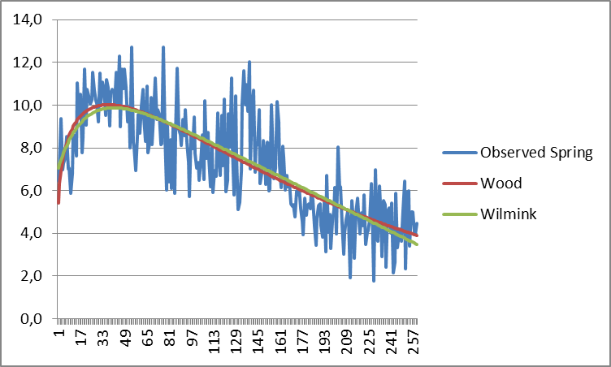
Figure 2. Lactation curves of Wood and Wilmink models for calving season of spring.

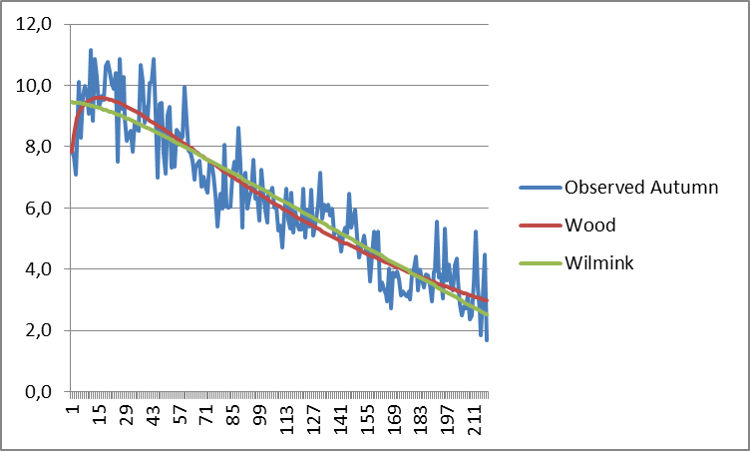
Figure 3. Lactation curves of Wood, Wilmink models for calving season of autumn

Present study, Wood, Wilmink and Cobby and Le Du models were used. Furthermore, among the models used, the highest coefficient of determination was determined for the Wood model for all groups. Nevertheless, Şahin et al. (2013), have compared Wood, Cobby and Le Du, exponential, parabolic exponential, inverse polynomial, quadratic, Logarithmic Quadratic and Logarithmic Linear models were used in the conduct of this study. Subsequently, it is detected that quadratic logarithmic and quadratic models that produce the highest R² and the lowest RSD values. Gürcan et al. (2011) have used quadratic logarithmic linear, logarithmic quadratic, linear hyperbolic, inverse polynomial and Wilmink models. Subsequently, among the models used in the research, the most suitable and the highest adjusted R² value was found in logarithmic quadratic model (0.97).
This study is showed that the daily milk yield records of first lactation for Italian water buffalo, Wood, Wilmink and Cobby and Le Du models were compared with fitness criteria. Ultimately, it is found that the Wood model has the best fitted model among all models for all groups. According to the data obtained from the animals used for the lactation curves.

References
Anonim (2014). TÜİK-Türkiye İstatistik Kurumu, Hayvancılık İstatistikleri. http://www.tuik.gov.tr/PreTabloArama.do, (20.09.2014).
Akbulut Ö, Emsen H, (1994). Atatürk Üniversitesi Tarım İşletmesinde yetiştirilen Esmer, ileri kan dereceli Esmer melezleri ile Siyah Alaca sığırların süt verim özellikleri ve laktasyon eğrisi parametrelerine etkili faktörler. Atatürk Üniversitesi Ziraat Fakültesi Dergisi, 25 (3), 327-343.
Cobby JM, Le Du YLP, (1978). On fitting curves to lactation data. Anim. Prod. 26 127-133.
Catillo G, Macciotta NPP, Carretta A, Cappio-Borlino A, (2002). Effects of age and calving season on lactation curves of milk production traits in Italian water buffaloes. J. Dairy Sci. 85:1298–1306.
Dimauro C, Catillo G, Bacciu N, Macciotta NPP, (2005). Fit of different linear models to the lactation curve of Italian water buffalo. Ital.J.Anim.Sci. Vol. 4 (suppl. 2), 22-24, 2005.
Garcia Y, Fraga LM, Tonhati H, Abreud D, Aspilcueta R, Hernandez A, Padron E, Guzman G, Mora M, Quinonez D, (2013). Genetic parameter estimates for milk yield and lactation length in buffalo. The 10th World Buffalo Congress and the 7th Asian Buffalo Congress, May 6-8, 2013, Phuket, Thailand.
Gürcan EK, Soysal MI, Küçükkebapçı M, Yüksel MA ve Genç S (2011). Mandaların laktasyon eğrisinin farklı modellerle karşılaştırılması. 7. Ulusal Zootekni Bilim Kongresi-Adana.
Hasanpur K, Aslaminejad AA, Kıanzad D, Naderfard HR, Seyyedalian SAR, Javanmard A, (2013). The Study of individual lactation curves of two Iranian buffalo ecotypes. The 10th World Buffalo Congress and the 7th Asian Buffalo Congress, May 6-8, 2013, Phuket, Thailand.
Kaygısız A, (1998). Yerli mandaların laktasyon eğrisi özellikleri. Kahramanmaraş Sütçü İmam Üniversitesi Ziraat Fakültesi Araştırma Fonu Projesi.
Kaygısız A, (1999). Yerli mandaların laktasyon eğrisi özellikleri. Tarım Bilimleri Dergisi, 5 (1), 1-8.
Khan MS, Chaudhry HZ, (2000). Lactation length and its behavior in Nili-Ravi Buffaloes. Pakistan Vet. J. 20 (2):2000.
Kreul W, Sarıcan C, (1993). Türkiye'de Manda Yetiştiriciliği. Hasad Dergisi Nisan Sayı:95 Yıl:8 Beyazıt-İstanbul.
Sahoo SK, Singh A, Shivahre PR, Singh M, Dash S, Dash SK, (2014). Prediction of Fortnightly Test-Day Milk Yields Using Four Different Lactation Curve Models in Indian Murrah Buffalo, Adv. Anim. Vet. Sci. 2 (12): 647-651.
Şahin A, Ulutaş Z, Yıldırım A, Yüksel A, Genç S, (2014). Anadolu mandalarında farklı laktasyon eğrisi modellerinin karşılaştırılması. Kafkas Üniversitesi Veteriner Fakültesi Dergisi, 20 (6): 847-855.
Şahin A, Ulutaş Z, Yıldırım A, Yüksel A, Genç S, (2015). Lactation curve and persistency of Anatolian buffaloes. Italian Journal of Animal Science 2015; volume 14:3679.
Malhado CHM, Ramos AA, Carneiro PLS, Souza JC, Carrillo JA, (2013). Genetic parameters for milk yield and lactation length of crossbred buffaloes from Brazil by Bayesian inference. The 10th World Buffalo Congress and the 7th Asian Buffalo Congress, May 6-8, 2013, Phuket, Thailand.
Muhammed A (2009). The animal of future. Idara matbuat-E-Sulemani, Lahore, Pakistan.
Özyurt A ve Özkan M, (2009). Orta Anadolu’ da yetiştirilen Siyah-Alaca sığırlarda laktasyon eğri şekli ve eğriye etkili olan faktörler. Hayvansal Üretim 50 (1):31-37.
Penchev P, Boichev M, Ilieva Y, Peeva TZ, (2011). Effect of different factors on lactation curve in buffalo cows. Slovak J. Anim. Sci., 44, 2011 (3): 103-110.
Soysal MI, Gürcan EK, (2000). Comparison of the mathematical models in fitting lactation curves for Black and White cattle raised in Tekirdağ and Kırklareli. 51. Annual Meeting of European Association for Animal Production, EAAP, 21-24/08, The Netherlands.
Soysal MI, Mutlu F, Gürcan EK, (2005). A study of the lactation biometry of Black and White dairy cows raised in private farms in Turkey. Trakia Journal of Sciences, 3 (6): 11-16, 2005.
Soysal MI, (2009). Manda ve ürünlerinin üretimi. Tekirdağ, Yayın no: 978-9944-5405-3-7, Sayfa:161-171, Tekirdağ.
Shokrollahi B, Hasanpur K, (2014). Study of individual lactation patterns of Iranian dairy buffaloes. Journal of Agriculture and Rural Development in the Tropics and Subtropics. Vol. 115 No. 2 (2014) 125–133.
Statistica, (1994). Statsoft Inc.Tulsaok, Statistica for The Windows TM. Operating System.
Thomas CS, (2008). Efficient dairy buffalo production. DeLaval International AB, Tumba, Sweden, 2008.
Wilmink JBM, (1984). Adjustment of test-day milk, fat and protein yield forage, season and stage of lactation. Livest. Prod. Sci. 16, 335-348.
Wood P.D.P. (1967). Algebraic model of lactation curve in cattle. Nature, 216, 164-1.

