The Determination of Milk Components for Anatolian Water Buffalo Raised In Istanbul

M.I. Soysal¹, E.K. Gurcan¹, M. Aksel²

¹ Namık Kemal University, Faculty of Agriculture, Department of Animal Science, Tekirdağ,
²Istanbul Water Buffalo Breeders Association, Istanbul.

Abstract
The study was aimed to determinate milk components of Anatolian water buffalo raised in Istanbul. Totally 1049 milk samples were used in this study. These samples were obtained from four different districts (Catalca, Arnavutkoy, Eyup, Silivri) and 12 villages in Istanbul. On the other hand, the samples were grouped as to their collection month (February, March, April, May). Fat percentage, protein percentage, dry matter percentage, lactose, freezing point were used on collected milk components. By that it was researched whether the milk components change according to districts and months and significant differences were found (P<0,01). The fat percentage was found as 8.04%, protein percentage 5.46%, dry matter percentage 18.21%, lactose percentage 5.20%, freezing point -0.53 °C for all samples.

Keywords: Milk Constituent, Water Buffalo Milk, Milk Component Analysis

Introduction
In this study was aimed to determinate milk components of Anatolian water buffalo. At the same time, It is intended to research the change in milk component for different districts and collection month in İstanbul province.
In Turkey, total number of buffaloes, number of milking buffaloes, and total buffalo milk production are 117591 head, 51940 head and 51947 tons in 2013, respectively. In 2012, the total number of buffalo, the number of milking buffalo, and the total buffalo milk production in İstanbul, were reported as 10560 head, 4994 head, and 5.362 tons, respectively. Approximately, 10% of the buffalo milk production of Turkey was obtained from İstanbul (Anonymous, 2014). There was a rapid decrease in the number water buffaloes of Turkey but in recent years, the number of buffalo has demonstrated a tendency to up increase (Gürcan et al. 2011).
Milk and meat products of buffalo are used mostly kaymak, yogurt, cheese, ice-cream and sucuk In Turkey. Buffalo's milk composition is different from cattle milk composition. Particularly, fat content of buffalo milk is higher than cattle milk.
The components of buffalo milk were researched for protein, total dry matter, fat, and water percentages as 4,1%, 17%, 8,1%, and 82,2%, respectively (Soysal et al. 1996). In terms of fat content, there are important differences among species. The average fat content of buffalo, cow, sheep, and goat are 7,7%, 3,4%, 7,2%, and 4,3%, respectively (Sosyal 2009). Madad et al. (2013) were reported that total milk yield was 1420,54 kg, fat yield was 99,83 kg, and percentage of fat was 7,01%, as average values. Muhammed et. al. (2009) has compared Pakistan Nili Ravi buffaloes, Indian Murrah buffaloes and Egyptian buffaloes. First lactation milk yields of Nili-Ravi, Murrah and Egyptian buffaloes were detected as 1854 kg, 1654 kg, and 1185 kg, respectively, while 3rd lactation milk yields were 2396, 2056, and 1678 kg and fat percentage values were 6.4, 6.6, and 6.5, in the same order. The fat, protein, lactose, dry matter, and water values of Chinese buffalo were found as 7,40-11,67%, 4,50-5,95%, 3,69-4,83%, 3,69-4,83%, and 78,24- 81,26%, respectively (Muhammed, et al. 2009).
Finally, present study is given to contribute the studies on the determination of water buffaloes’ milk characteristics.

Material and Method
The experiment material of this study were obtained from 1049 milk examples from 4 districts (Çatalca, Arnavutköy, Eyüp and Silivri) and 12 different villages from these districts (Nakkaş, Örcünlü; Baklalı, Boyalık, Dursunköy, Hacımaşlı, Tayakadın, Yassıören; Işıklar, Prinçci; Yolçatı, Büyüksinekli) in İstanbul. The samples were grouped as districts (Çatalca, Arnavutköy, Eyüp and Silivri) and collection month (February, March, April, May). Fat percentage, protein percentage, dry matter percentage, lactose and freezing point were analyzed for milk components. The milk components were compared with variance analysis and Duncan’s multiple range tests according to districts (Statistica, 1994). Milk components were analyzed as automatically. The samples were transported to Istanbul Water Buffalo Breeders Association’s laboratory in cold chain. Following this, the milk samples were warmed up in water bath (in 40°C) and, fat, protein, lactose, dry matter values and freezing point were determined with Bentley DairySpec FT Fourier Transform Spectrometer (Figure 1). The device and its analysis methods are approved by international organizations.
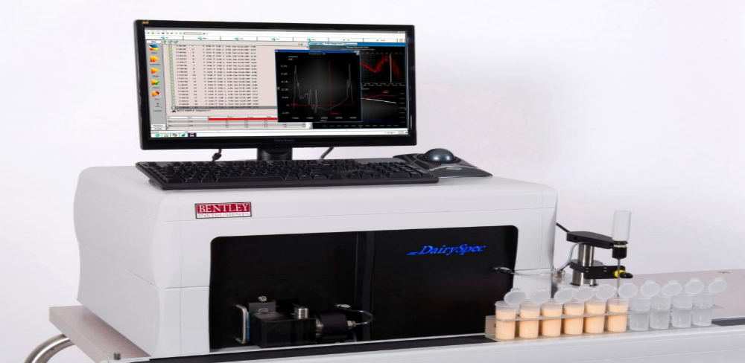
Figure 1. Bentley DairySpec FT Fourier Transform Spectrometer
Satellite map of the locations in the study, from which samples were collected, is shown in Figure 2.
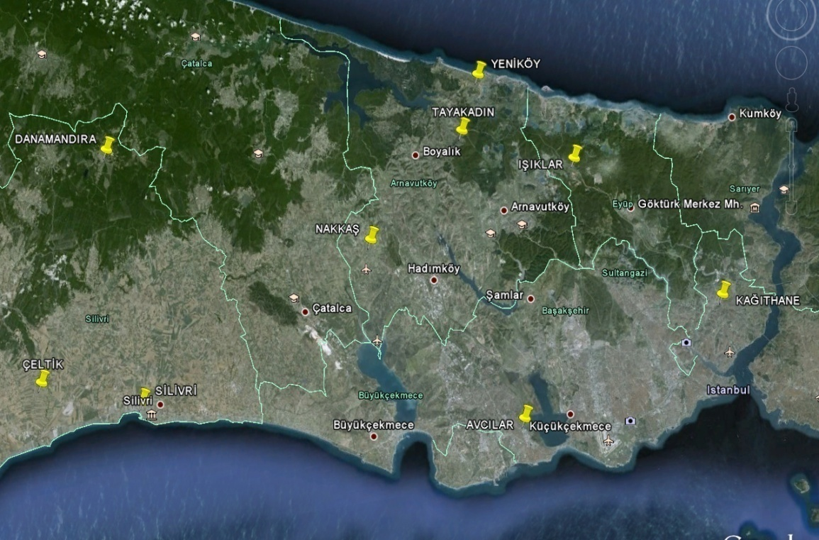
Figure 2. Satellite map of the locations in present study

Results and Discussion
The general descriptive statistics were given for milk components in table 1. The fat percentage was found as 8.04%, protein percentage 5.46%, dry matter percentage 18.21%, lactose percentage 5.20% and freezing point -0.53 °C for all samples.
Table 1. The general descriptive statistics for milk components
Milk component | N | Min | Max | Mean | Standart Error
Fat percentage | 1049 | 0,30 | 18,38 | 8,04 | 0,078
Protein percentage | 1049 | 0,06 | 5,46 | 3,83 | 0,018
Dry matter percentage | 1049 | 6,32 | 29,33 | 18,21 | 0,081
Lactose percentage | 1049 | 1,72 | 6,13 | 5,20 | 0,015

The descriptive statistics and results of Duncan’s multiple range tests were given for milk components according to district in table 2. The maximum fat percentage, protein percentage and dry matter percentage were found as 8.34%, 4,06% and 18,21% in Eyüp respectively.
Table 2. The descriptive statistics and results of Duncan’s multiple range tests for milk components according to district
Milk component % | District | N | Mean | Standart Error | P
Fat | Çatalca | 393 | 7,96a | 0,137 | 0,005
Fat | Arnavutköy | 390 | 8,04a | 0,131 | 0,005
Fat | Eyüp | 233 | 8,34a | 0,125 | 0,005
Fat | Silivri | 33 | 6,72b | 0,503 | 0,005
Protein | Çatalca | 393 | 3,84b | 0,029 | 0,000
Protein | Arnavutköy | 390 | 3,73b | 0,027 | 0,000
Protein | Eyüp | 233 | 4,06a | 0,030 | 0,000
Protein | Silivri | 33 | 3,38c | 0,23 | 0,000
Dry Matter | Çatalca | 393 | 18,04b | 0,146 | 0,000
Dry Matter | Arnavutköy | 390 | 18,22ab | 0,129 | 0,000
Dry Matter | Eyüp | 233 | 18,81a | 0,134 | 0,000
Dry Matter | Silivri | 33 | 16,14c | 0,447 | 0,000
Lactose | Çatalca | 393 | 5,05b | 0,029 | 0,000
Lactose | Arnavutköy | 390 | 5,34a | 0,019 | 0,000
Lactose | Eyüp | 233 | 5,29a | 0,020 | 0,000
Lactose | Silivri | 33 | 4,86c | 0,177 | 0,000
The descriptive statistics and results of Duncan’s multiple range tests were given for milk components according to collection month (February, March, April, May) in table 3. The maximum fat percentage, lactose percentage and dry matter percentage were found as 8.31%, 5,25% and 18,49% in march respectively.

Table 3. The descriptive statistics and results of Duncan’s multiple range tests for milk components according to district
Milk component % | Month | N | Mean | Standart Error | P
Fat | February | 305 | 8,02ab | 0,15 | 0,000
Fat | March | 543 | 8,31a | 0,10 | 0,000
Fat | April | 167 | 7,37bc | 0,16 | 0,000
Fat | May | 34 | 6,96c | 0,07 | 0,000
Protein | February | 305 | 3,78c | 0,03 | 0,008
Protein | March | 543 | 3,87ab | 0,02 | 0,008
Protein | April | 167 | 3,75c | 0,05 | 0,008
Protein | May | 34 | 4,04a | 0,07 | 0,008
Dry Matter | February | 305 | 18,27a | 0,15 | 0,000
Dry Matter | March | 543 | 18,49a | 0,11 | 0,000
Dry Matter | April | 167 | 17,39a | 0,16 | 0,000
Dry Matter | May | 34 | 17,39a | 0,26 | 0,000
Lactose | February | 305 | 5,20ab | 0,03 | 0,000
Lactose | March | 543 | 5,25a | 0,01 | 0,000
Lactose | April | 167 | 5,06b | 0,04 | 0,000
Lactose | May | 34 | 5,18ab | 0,05 | 0,000

The descriptive statistics and results of Duncan’s multiple range tests were given for freezing point °C according to district and months in table 4. The maximum freezing point were found as -0.53 °C in Çatalca and Eyüp respectively. The maximum freezing point were found as -0.55 °C in may respectively.

Table 4. The descriptive statistics and results of Duncan’s multiple range tests for milk components according to district
 |  | N | Mean | Standart Error | P
District | Çatalca | 362 | -0,53a | 0,001 | 0,00
District | Arnavutköy | 286 | -0,52a | 0,001 | 0,00
District | Eyüp | 207 | -0,53a | 0,002 | 0,00
District | Silivri | 33 | -0,50b | 0,01 | 0,00
Months | February | 173 | -0,54ab | 0,002 | 0,00
Months | March | 514 | -0,51a | 0,001 | 0,00
Months | April | 167 | -0,54b | 0,003 | 0,00
Months | May | 34 | -0,55a | 0,002 | 0,00

Result
Similarly, İlaslan et al. (1983) have reported that fat content in buffalo milk, was ranging between 6.26% and 9.72%, accordingly, they calculated the mean fat as 8%. Soysal et al. (1996), have determined percentages of protein, dry matter, fat, and water, to be 4,1%, 17%, 8,1%, and 82,2%, respectively.
Finally, the milk components according to districts and months were compared and significant differences were found as statistically. The fat percentage was found as 8.04%, protein percentage 5.46%, dry matter percentage 18.21%, lactose percentage 5.20%, freezing point -0.53 °C for all samples.

References
Anonymous (2014). TÜİK-Türkiye İstatistik Kurumu, Hayvancılık İstatistikleri. http://www.tuik.gov.tr/PreTabloArama.do, (20.09.2014).
Gürcan EK, Soysal MI, Küçükkebapçı M, Yüksel MA ve Genç S (2011). Mandaların laktasyon eğrisinin farklı modellerle karşılaştırılması. 7.Ulusal Zootekni Bilim Kongresi, Adana.
İlaslan M, Karabulut A, Aşkın Y, İzgi AN (1983). Yerli Mandalarda Vücut Yapısı, Döl ve süt Verimi üzerine Araştırmalar. Afyon Zirai Araştırma İstasyonu Yayın No: 14 Afyon.
Madad M, Hossein-Zahed NG and Shadparvar AA (2013). A Study of Some Factors Affecting on Productive Traits in Azari Buffaloes of Iran. The 10th World Buffalo Congress and The 7thAsian Buffalo Congress May 6-8, 2013, Phuket, Thailand
Muhammed A (2009). The Animal of Future. Idara Matbuat-E-Sulemani, Lahore, Pakistan.
Soysal Mİ (2009). Manda ve Ürünlerinin Üretimi. Tekirdağ, Yayın no: 978-9944-5405-3-7 , Sayfa: 161-171, Tekirdağ.
Soysal Mİ, Küçük R (1996). Siyah Alaca Süt Sığırlarında Eklemeli Kısmi Verimler İle Birinci Laktasyon Süt Veriminin Tahmin Olanakları Üzerine Bir Araştırma. Tekirdağ Ziraat Fakültesi Dergisi S.284-293 1996.
Statistica, (1994). Statsoft Inc.Tulsaok, Statistica for The Windows TM.Operating System.

