The Comparison of Lactation Curve with Different Models in Mediterranean Water Buffalo Raised in Istanbul

M.I. Soysal¹, E.K. Gurcan¹, M. Aksel²

¹ Namık Kemal University, Faculty of Agriculture, Department of Animal Science, Tekirdag- Turkey
²Istanbul Water Buffalo Breeders Association, Istanbul- Turkey

Abstract
This study was aimed to investigate biometry of lactation curve for Mediterranean water buffalo imported from Italy raised in private farm in Turkey. Total 72 head Italian water buffalo were used at first lactation and three calving seasons as animal material. Wood, Wilmink and Cobby and Le Du models were chosen in present study. The general average lactation period, total lactation milk yield average and average daily milk yield were found 234 days, 1607.4 kg and 6.86 kg, respectively. Determination coefficient was calculated for Wood, Wilmink and Cobby and Le Du models for summer calving season as 0.94, 0.92 and 0.93, respectively. Wood model was found the highest coefficient of determination in general. Moreover, persistency (S) and maximum milk yields (Y_{max}) for Wood model were calculated. These values were found as 5.89 and 9.76 for first lactation in general group, respectively.

Keywords: Wood, Wilmink, Cobby and Le Du Models, Mediterranean Water Buffalo, Lactation Curve.

Introduction
Water buffalo is an important animal between the other farm animals from the point of milk and meat production. Recently, In spite of the fact that the breeding is still generally done under primitive conditions the water buffalo population is increasing in Turkey. Water buffalo milk is used in production of kaymak, cheese, and ice-cream. Also, buffalo meat is used in sausage production. Especially, buffalo milk is fatter than cow’s milk with a fat content of 7-8% (Soysal 2009). By the end of lactation, fat content increases more, and besides that it may reach to the levels of 12,5-15% (Düzgüneş 1960; Kreul and Sarıcan 1993). Considering statistical data, in 2013, the total number of water buffalo has increased to 117591 heads, the number of milking water buffalo has increased to 51940 heads and the amount of water buffalo milk production has reached to 51,947 tons (Anonymous 2014).
Many studies have realized about water buffalo breeding as to increase water buffalo production on the world.
Nili Ravi buffaloes’ average lactation period and average lactation milk yield were found 317 days and 2219 kg in Pakistan, respectively. Furthermore, the first lactation milk yields were found in Nili Ravi, Murrah, and Egyptian buffaloes as 1854, 1654 and 1185, respectively. As to Italian buffaloes the producing was found as 2587 kg of milk on average 322,9 days (Muhammed, 2009). Malhado et al. (2013) have found milk yield and lactation period of hybrid buffaloes as 1546 kg and 252.3 days, respectively. Hasanpur et al. 2013 are showed in which some environmental factors and traits of various lactation curves. In this study, calving age, calving season, year of birth and year of calving were found statistically important factors on the lactation curve characteristics (P <0.05). In addition to this, it was reported that non-genetic factors have a significant role in determination of total milk yield and lactation in buffaloes.
Garcia et al. (2013), are reported that 244-day mean milk yield and lactation period were 864 kg and 240 days, respectively. Additionally, while the heritability of milk yield and lactation length were detected to be 0.15 and 0.13, respectively, the genetic correlation between these properties, has found to be 0,63.
Lactation curve’s shape is a significant criteria. It is possible to draw some conclusions on lactation milk yield of animal. For instance, an animal showing little change during lactation is more preferable than an animal giving a large part of milk at the beginning and a little amount after peak yield. In this case, the first animal’s curve is called flat lactation curve, and the second animal’s curve is called the steep lactation curve. In animal breeding practice, animals with flat lactation curve, are preferred over the ones with steep lactation curve (Akbulut et al. 1994). Moreover, Soysal and Mutlu (2005); Kaygısız (1998) are stated that using partial lactation records, lactation curve may be employed in a method of estimating total lactation yield.
Logarithmic, logarithmic quadratic, gamma, Wood, Goodall and Grossman and such models were used by Kaygısız (1999) in Turkey, Barbosa et al. (2007) in Italy and Aziz et al. in Egypt. In a study, models were used called quadratic logarithmic linear, logarithmic quadratic, linear hyperbolic, inverse polynomial and Wilmink models by comparing different models of lactation curve. Moreover, the highest adjusted determination coefficient was detected in logarithmic quadratic model (0.97) and has indicated as the adjusted determination coefficient of Wilmink model was 0.86 (Gurcan et al., 2011). Şahin et al. (2013), have compared different lactation curve models of Anatolian water buffaloes. In this study, Wood, Cobby and Le Du, exponential, parabolic exponential, inverse polynomial, quadratic, logarithmic quadratic and logarithmic linear models were used in defining lactation curve. The results indicated that quadratic logarithmic and quadratic models that produce the highest R² and the lowest RSD values are showing the best fit.
In this study, daily milk yield records of Italian water buffaloes were used in modelling lactation curves for first lactation with three calving seasons and determining the most suitable model.
Material and Method
Animal material consisted of total 72 heads Italian water buffalo raised in İstanbul. Milk yield records were taken as daily during lactation and which were in the first lactation periods. All animal were grouped to calving season as summer, spring and autumn. The change in yield with respect to time is researched with Wood, Wilmink and Cobby models (Wood, 1967; Wilmink 1987, Cobby and Le Du 1978). From another hand, in determination of the most appropriate one among the models used determination coefficients (R²) and Residual Standart Deviation (RSD) were utilized. RSD=[RSS/(n-p)]^{1/2} and RSS is Residual Sum of Squares, n is the number of observation and p is the number of the parameters. The functions of models (Wood, Wilmink, Cobby and Le Du) have been indicated in Table 1. Modelling processes and parameter estimates of the models used were made in statistical package software Statistica (Statistica, 1994).
Table 1. The models and functions
Models | Functions
Wood | Y_{(t)}=at^{b} e^{-ct}
Wilmink | Y_{(t)}=a + be^{-kt} + ct
Cobby and Le Du | Y_{(t)}=a – bt – ae^{-ct}

Parameter estimates for each one of the models, have been made. Depending on the characteristics of model used in parameter estimation, a, b, c, and k parameters as initial milk yield, pre-peak increase rate, post-peak decline rate, and peak-reach time, respectively and in the this research k parameters was assumed equal to 0,05 for Wilmink model (Özyurt and Özkan 2009). Moreover, In the study, persistence (S) values for Wood’s model, has been found to be S = -(1+b).lnc. The day that the highest milk yield was obtained (T_{max}) and maximum milk yield (Y_{max}), have been calculated to be T_{max}=b/c and Y_{max}=a(b/c)^{b}e^{-b}, respectively (Soysal and Gurcan 2000).
Results and Discussion
At present study, milk yield records of 72 heads Italian water buffalo, have been kept to be used in modelling lactation curve. Additionally, the lowest milk yield and the highest total milk yield were found to be autumn and spring calving seasons as 1260.2 kg and 1780.4 kg, respectively. However, among the animals of which yield records were taken to first lactation, average lactation period was calculated as 234 days and average daily milk yield were calculated as 6.86 kg in general. The results are shown at table 2.
Table2. Lactation period (day), total milk yield (kg) and average daily milk yield (kg) according to calving seasons
Calving Seasons | N | Lactation period | Total milk yield | Average daily milk yield
Spring | 5 | 236 | 1780,4 | 7,54
Summer | 59 | 239 | 1639,4 | 6,85
Autumn | 8 | 192 | 1260,2 | 6,58
General | 72 | 234 | 1607,4 | 6,86

In the study conducted to model lactation curve of the water buffalo, of which milk yield records were kept, Wood, Wilmink and Cobby and Le Du models were utilized. The parameters estimations related to these models are demonstrated in Table 3. According to the results, initial milk yields of summer calving season for Wood, Wilmink and Cobby and Le Du models were detected as 7.90 kg, 10.42 kg and 10.20 kg, respectively. Subsequently, in the same order, determination coefficients were determined as 0.94, 0.92, and 0.93, respectively. Accordingly, among the models studied, Wood model was the one with the highest determination of coefficient for all calving season.
Table 3. Parameter estimations according to Wood, Wilmink and Cobby and Le Du models for calving season
Calving Seasons | Models | a | b | c | R² | RSD
Summer | Wood | 7,90 | 0,098 | 0,0044 | 0,94 | 1,00
 | Wilmink | 10,42 | -1,328 | -0,024 | 0,92 | 1,17
 | Cobby and Le Du | 10,20 | 0,022 | 0,8419 | 0,93 | 1,09
Spring | Wood | 5,45 | 0,232 | 0,0062 | 0,64 | 16,85
 | Wilmink | 11,84 | -4,99 | -0,032 | 0,63 | 16,88
Autumn | Wood | 7,88 | 0,112 | 0,0072 | 0,88 | 5,34
 | Wilmink | 10,11 | -0,66 | -0,034 | 0,85 | 5,76
R²= Determination Coefficient, , RSD=Residual Standard Deviation
On the other hand, values of persistency (S), maximum milk yield (Y_{max}) and time of the maximum milk yield (T_{max}), which belong to Wood model, are presented in Table 4 for all calving seasons. Accordingly, for Wood model, persistency values was 5.89, Y_{max} values was 9.76 and T_{max} values was 25.07 for general groups, respectively.
Table 4. Persistence, Y_{max} and T_{max} values of Wood models according to calving seasons
Calving Seasons | S | Y_{max} | T_{max}
Summer | 5,95 | 9,70 | 22,27
Spring | 6,26 | 10,01 | 37,41
Autumn | 5,48 | 9,57 | 15,55
General | 5,89 | 9,76 | 25,07

The change in observed yield and predicted yield with respect to time is demonstrated in Figure 1, 2 and 3.
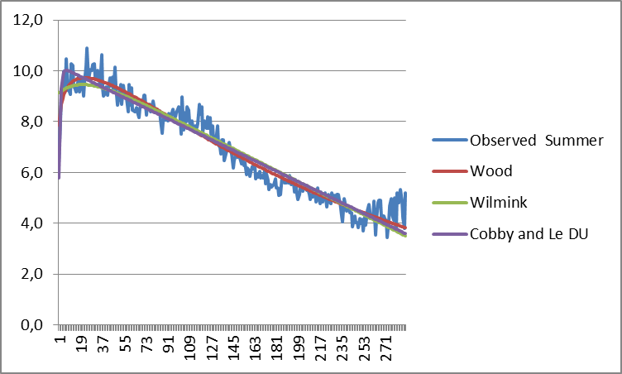
Figure 1. Lactation curves of Wood, Wilmink and Cobby and Le Du models for calving season of summer.
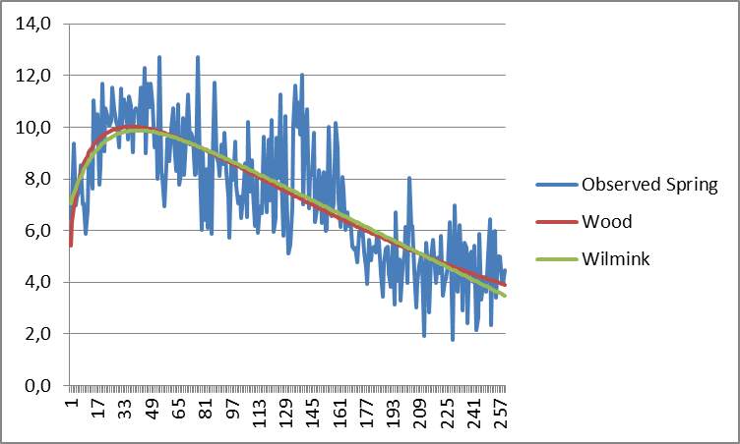
Figure 2. Lactation curves of Wood and Wilmink models for calving season of spring.
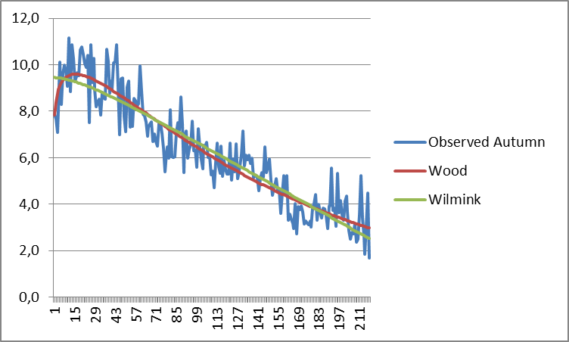
Figure 3. Lactation curves of Wood, Wilmink models for calving season of autumn.
Present study, Wood, Wilmink and Cobby and Le Du models were used. Furthermore, among the models used, the highest coefficient of determination was determined for the Wood model for all groups. Nevertheless, Şahin et al. (2013), have compared Wood, Cobby and Le Du, exponential, parabolic exponential, inverse polynomial, quadratic, Logarithmic Quadratic and Logarithmic Linear models were used in the conduct of this study. Subsequently, it is detected that quadratic logarithmic and quadratic models that produce the highest R² and the lowest RSD values. Gurcan et al. (2011) have used quadratic logarithmic linear, logarithmic quadratic, linear hyperbolic, inverse polynomial and Wilmink models. Subsequently, among the models used in the research, the most suitable and the highest adjusted determination coefficient value was found in logarithmic quadratic model (0.97).
This study is showed that the daily milk yield records of first lactation for İtalian water buffalo, Wood, Wilmink and Cobby and Le Du models were compared with fitness criteria. Ultimately, it is found that the Wood model has the best fitted model among all models for all groups. According to the data obtained from the animals used for the lactation curves.
References
Anonim (2014). TÜİK-Türkiye İstatistik Kurumu, Hayvancılık İstatistikleri. http://www.tuik.gov.tr/PreTabloArama.do, (20.09.2014).
Akbulut Ö, Emsen H, (1994). Atatürk Üniversitesi Tarım İşletmesinde yetiştirilen Esmer, ileri kan dereceli Esmer melezleri ile Siyah Alaca sığırların süt verim özellikleri ve laktasyon eğrisi parametrelerine etkili faktörler. Atatürk Üniversitesi Ziraat Fakültesi Dergisi, 25 (3), 327-343.
Barbosa SBP, Pereira RGA, Santoro KR, Batista AMV, Ribeiro Neto AC (2007). Lactation curve of cross-bred buffalo under two production systems in the Amazonian region of Brazil. Ital. J. Anim. Sci. 6, (Suppl.2), 1075-1078.

Cobby JM, Le Du YLP (1978). On fitting curves to lactation data. Anim. Prod. 26 127-133.
Düzgüneş O (1960). Hayvancılık. Ziraat Vekaleti Mesleki Kitaplar Serisi: D-l. Ankara
Garcia Y, Fraga LM, Tonhati H, Abreud D, Aspilcueta R, Hernandez A, Padron E, Guzman G, Mora M and Quinonez D (2013). Genetic parameter estimates for milk yield and lactation length in buffalo. The 10th World Buffalo Congress and the 7th Asian Buffalo Congress, May 6-8, 2013, Phuket, Thailand
Gurcan EK, Soysal MI, Küçükkebapçı M, Yüksel MA ve Genç S (2011). Mandaların laktasyon eğrisinin farklı modellerle karşılaştırılması. 7. Ulusal Zootekni Bilim Kongresi-Adana.
Hasanpur K, Aslaminejad AA, Kıanzad D, Naderfard HR, Seyyedalian SAR and Javanmard A (2013). The Study of individual lactation curves of two Iranian buffalo ecotypes. The 10th World Buffalo Congress and the 7th Asian Buffalo Congress, May 6-8, 2013, Phuket, Thailand.
Kaygısız A, (1998). Yerli mandaların laktasyon eğrisi özellikleri. Kahramanmaraş Sütçü İmam Üniversitesi Ziraat Fakültesi Araştırma Fonu Projesi.
Kaygısız A (1999). Yerli mandaların laktasyon eğrisi özellikleri. Tarım Bilimleri Dergisi, 5 (1), 1-8.

Kreul W, Sarıcan C (1993). Türkiye'de manda yetiştiriciliği. Hasad Dergisi Nisan Sayı:95 Yıl:8 Beyazıt-İstanbul.
Şahin A, Ulutaş Z, Yıldırım A, Yüksel A, Genç S. (2014). Anadolu mandalarında farklı laktasyon eğrisi modellerinin karşılaştırılması. Kafkas Üniversitesi Veteriner Fakültesi Dergisi, 20 (6): 847-855.
Malhado CHM, Ramos AA, Carneiro PLS, Souza JC and Carilo JA (2013). Genetic parameters for milk yield and lactation length of crossbred buffaloes from Brazil by Bayesian inference. The 10th World Buffalo Congress and the 7th Asian Buffalo Congress, May 6-8, 2013, Phuket, Thailand.
Muhammed A (2009). The animal of future. Idara matbuat-E-Sulemani, Lahore, Pakistan.
Özyurt A ve Özkan M, (2009) Orta Anadolu’ da yetiştirilen Siyah-Alaca sığırlarda laktasyon eğri şekli ve eğriye etkili olan faktörler. Hayvansal Üretim 50 (1):31-37.
Soysal MI, Gürcan EK (2000). Comparison of the mathematical models in fitting lactation curves for Black and White cattle raised in Tekirdağ and Kırklareli. 51. Annual Meeting of European Association for Animal Production, EAAP, 21-24/08, The Netherlands.
Soysal MI, Mutlu F, Gürcan EK: A study of the lactation biometry of Black and White dairy cows raised in private farms in Turkey. Trakia Journal of Sciences, 3 (6): 11-16, 2005.
Soysal MI (2009). Manda ve ürünlerinin üretimi. Tekirdağ, Yayın no: 978-9944-5405-3-7, Sayfa:161-171, Tekirdağ.
Statistica, (1994). Statsoft Inc.Tulsaok, Statistica for The Windows TM. Operating System.
Wilmink JBM (1984). Adjustment of test-day milk, fat and protein yield forage, season and stage of lactation. Livest. Prod. Sci. 16, 335-348.
Wood P.D.P. (1967). Algebraic model of lactation curve in cattle. Nature, 216, 164-1.

